FUNCTIONAL REQUIREMENTS DOCUMENT FOR
QUICK TEMPERATURE

Contents:

- Introduction 3

1.1. Purpose 3

1.2. Intended Audience 3

2. Functional Requirements 3

2.1. Temperature Converter Page 3

2.2. Conversion Logic 4
2.3. City Temperature page 7

- Introduction
The functional requirement document provides a complete description of the features of the Quick Temperature Webpage. It outlines how users interact with the application and how the webpage responds to their actions.
  - Purpose
The purpose of this document is to define the functional requirements for the Quick Temperature Webpage. This document will help the intended audience understand the behaviour and flow of the application.
  - Intended Audience:
- Development Team
- QA Team
- Business Analyst
- UI/UX Team

- Functional Requirements
When the user types the URL https://shaik-mohammed-amaan.github.io/quick-temperature/ it should navigate to the Temperature Converter website.
Other URL to visit website: https://quick-temperature-zeta-umber.vercel.app/
Code URL: https://github.com/Shaik-Mohammed-Amaan/quick-temperature
2.1 Temperature Converter Page
- When the user enters the application URL, it should navigate to the homepage of the Temperature Converter Webpage
- This page contains the following sections:
- Two toggle buttons to navigate between Temperature Converter Page and City Temperature Page
- Header/title indicating "Temperature Converter"
- A dropdown or selection for source temperature unit (Celsius, Fahrenheit, Kelvin)
- An input box to enter the temperature value
- A "Convert" button to trigger conversion
- A result display area showing the converted value

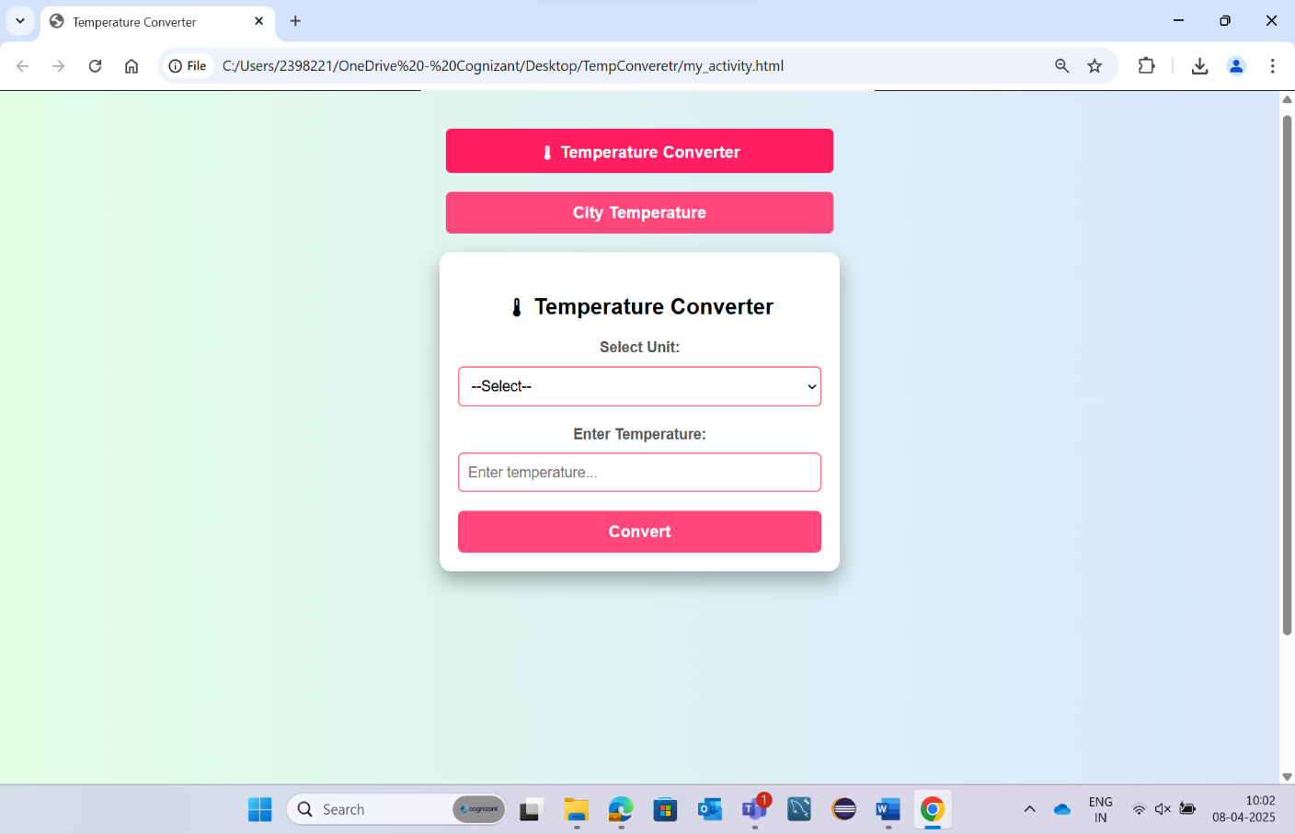
Fig: Temperature Converter Home Page

2.2 Conversion Logic
- Users can select the temperature units from the drop-down menu.
- Users can input a numeric temperature value.
- On clicking "Convert", the system performs the conversion based on standard temperature conversion formulas:
- Celsius to Fahrenheit: (C × 9/5) + 32
- Celsius to Kelvin: C + 273.15
- Fahrenheit to Celsius: (F - 32) × 5/9
- Fahrenheit to Kelvin: (F - 32) × 5/9 + 273.15
- Kelvin to Celsius: K - 273.15
- Kelvin to Fahrenheit: ((K - 273.15) x 9/5) + 32

If the user directly clicks on the convert button without selecting the temperature unit from the drop down menu and without entering the temperature value, it will show the below message as validation.
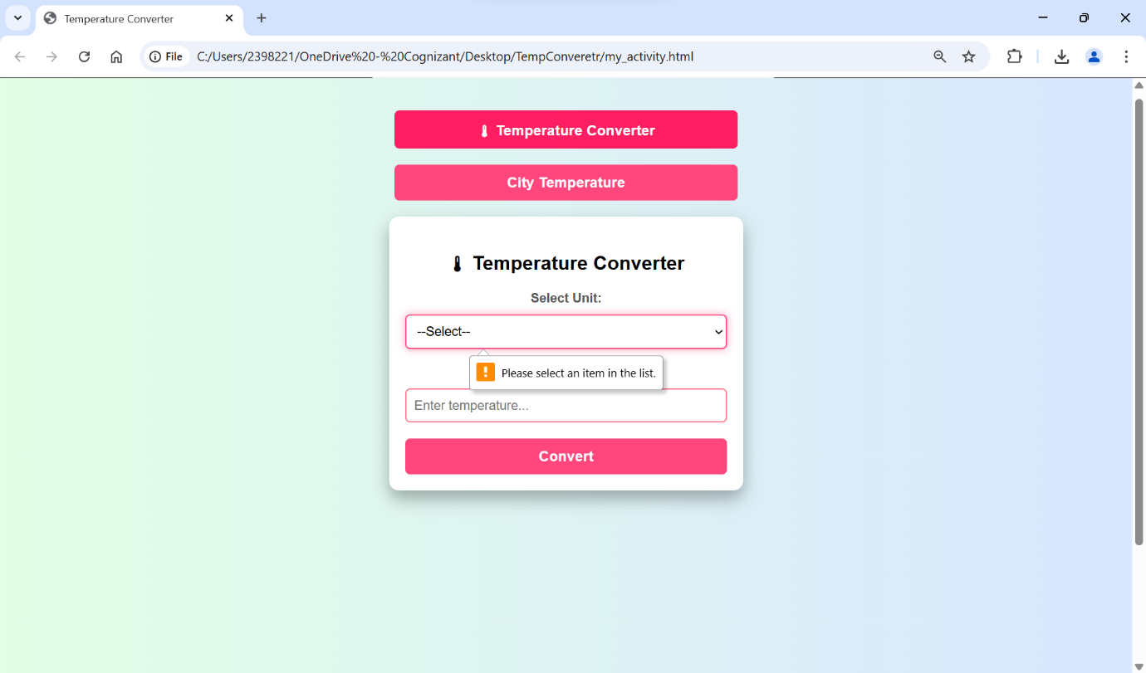

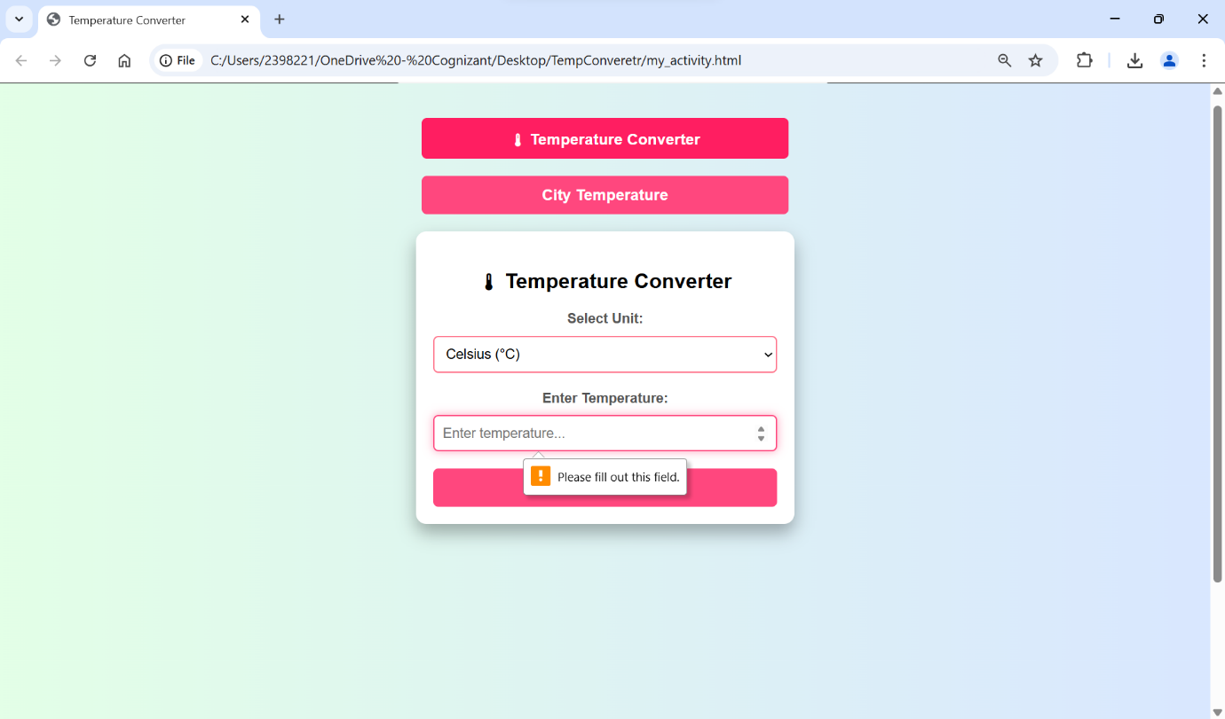

If the user enters valid inputs and temperature value, then the background gradient changes as Convenient to the temperature. If temperature is below 20, it will snow, if the temperature is between 20-30 the background will have some warm sunny gradient and if the temperature is above 30, sun will pop up accordingly. And the converted temperature values are shown in the result box as below.
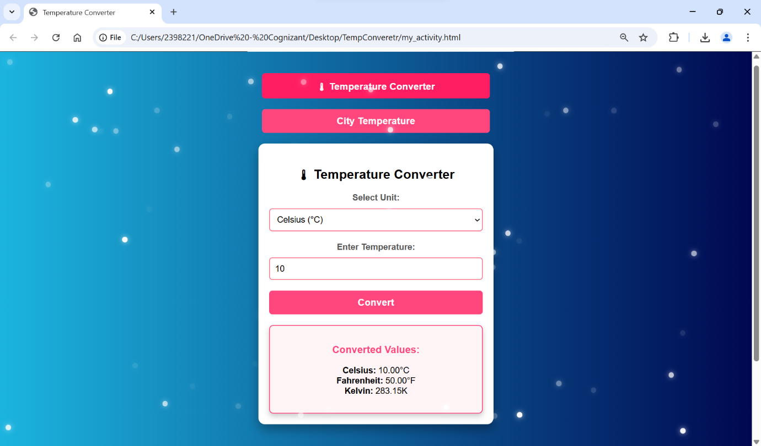
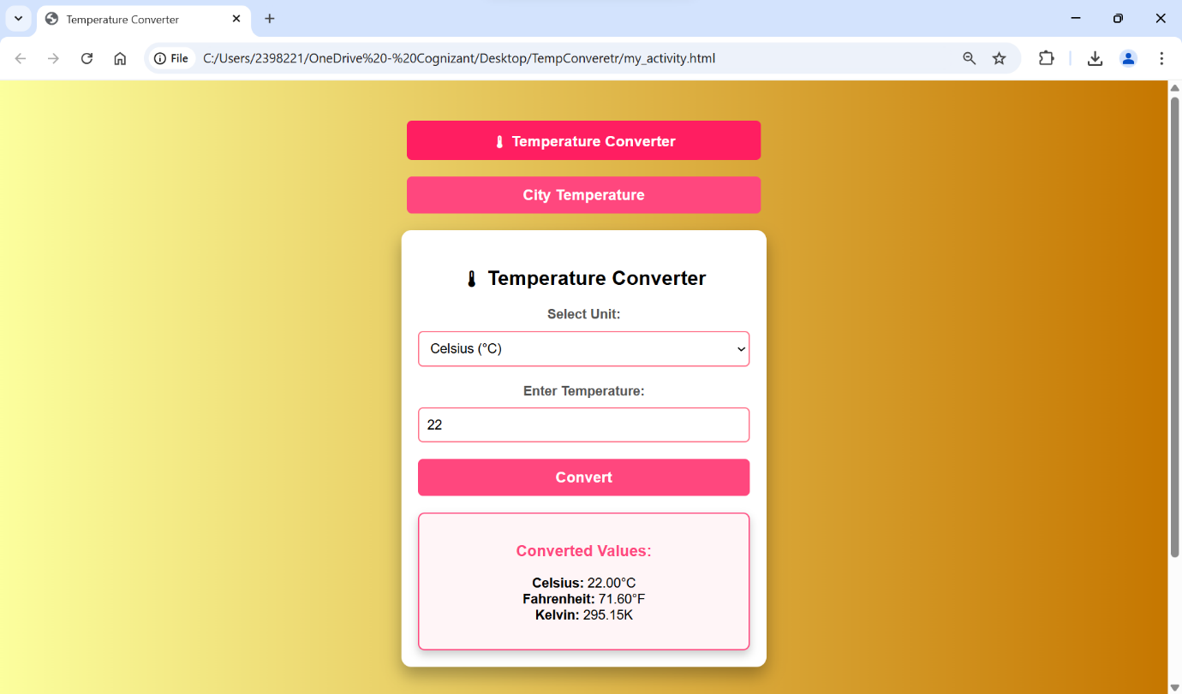
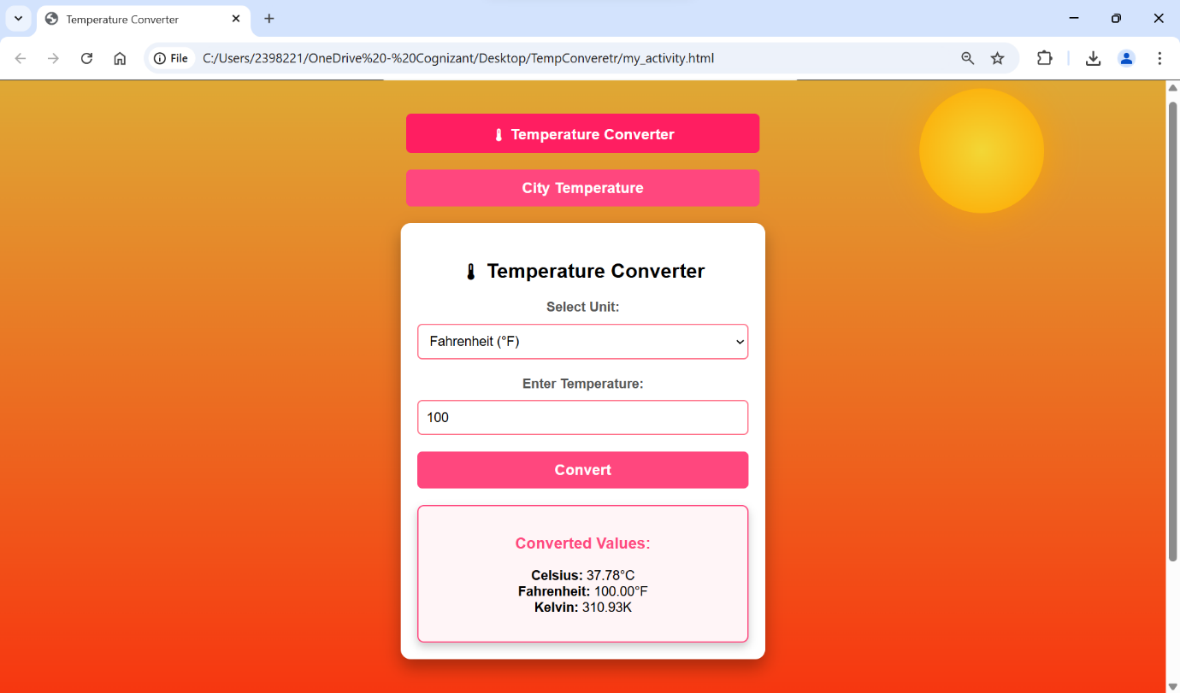

2.3 City Temperature Page
- A separate section or tab that allows users to:
- Enter a city name
- Fetch and display current temperature data (OpenWeather API)
- Show a temperature trend chart using a bar chart
- Display the city temperature in Celsius, Fahrenheit and kelvin units in the result box

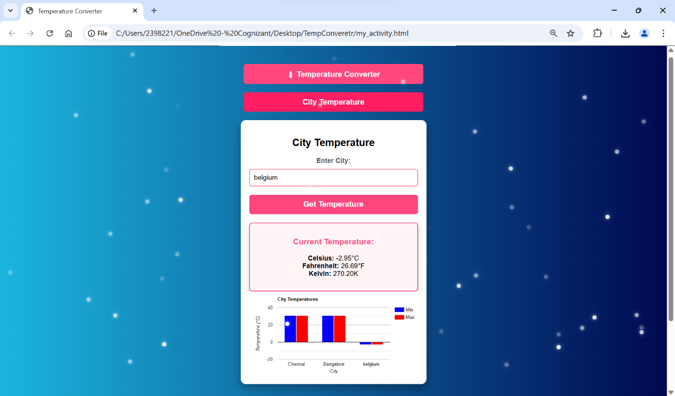

If the user directly clicks on the Get Temperature button without entering the name of the city, then it will show the below message as validation.
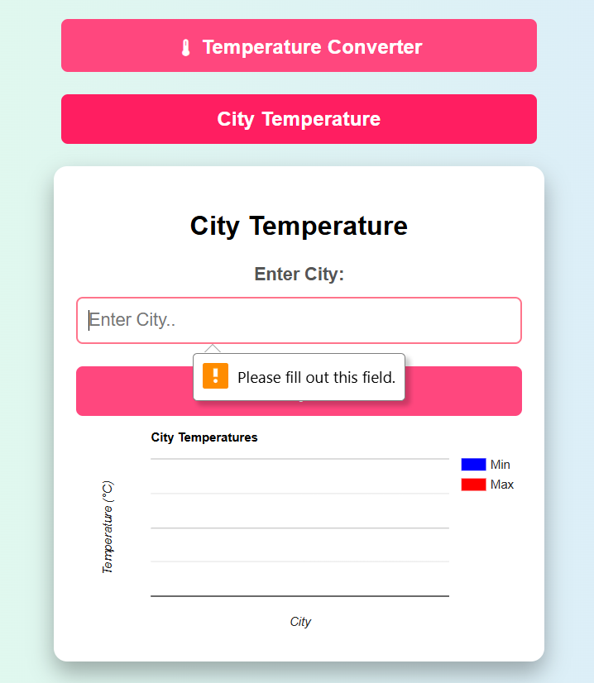

If the user enters the wrong city name, then it will show the alert box as below.
